

FRESHMAN ENGINEERING DEPARTMENT

A Project Based Lab Report On

                                  GARAGE SYSTEM

SUBMITTED BY:

190040507 S.Abdul Raheem

190040473 SM.J.Hussain

190040489 CH.Sravya

190040505 S.Swetha Priya

                                                UNDER THE GUIDANCE OF

                                          Mr.C.M.A.K.ZEELAN BASHA



KL UNIVERSITY

Green fields, Vaddeswaram – 522 502

Guntur ,A.P.

        DEPARTMENT OF BASIC ENGINEERING SCIENCES -1



CERTIFICATE

This is to certify that the project based laboratory report entitled “GRAPHIC USER INTERFACE” submitted by SM.J.Hussain, S.AbdulRaheem,S.Swetha Priya,CH.Sravya bearing Regd. No. 190040507, 190040473, 190040505, 190040489  to the Department of  Basic Engineering Sciences-1 , KL University in partial fulfilment of the requirements for the completion of a project based Laboratory in “OBJECT ORIENTED PROGRRAM ”course in  B Tech II Semester, is a bonafede record of the work carried out by him under my supervision during the academic year 2019 – 2020.

PROJECT SUPERVISOR HEAD OF THE DEPARTMENT

Mr.C.M.A.K.ZEELAN BASHA                                           Dr D. HARITHA

ACKNOWLEDGEMENT

It is great pleasure for me to express my gratitude to our honorable President Sri. Koneru Satyanarayana, for giving the opportunity and platform with facilities in accomplishing the project based laboratory report.

I express the sincere gratitude to our Director Dr.A.Jagadeesh for his administration towards our academic growth.

I express sincere gratitude to HOD-BES-1 Dr.D.Haritha for his leadership and constant motivation provided in successful completion of our academic semester. I record it as my privilege to deeply thank for providing us the efficient faculty and facilities to make our ideas into reality.

I express my sincere thanks to our project supervisor Mr.C.M.A.K.Zeelan Basha for his novel association of ideas, encouragement, appreciation and intellectual zeal which motivated us to venture this project successfully.

Finally, it is pleased to acknowledge the indebtedness to all those who devoted themselves directly or indirectly to make this project report success.

SUBMITTED BY:

190040507 S.Abdul Raheem

190040473 SM.J.Hussain

190040489 CH.Sravya

190040505 S.Swetha Priya

Contents Pg.no.

1. ABSTRACT  5
2. INTRODUCTION  6

3. CODE  7-12

4.OUTPUT 13-16

5. CLASS DIAGRAM 17

6.CONCLUSION 18

ABSTRACT

A garage owner wants to develop a GUI based program for the services you’re offering to help the customer’s in every possible way. It should contain separate buttons for 2,3,4 wheelers and also include an option of premium membership which gives the customer additional discount. Display the cost of servicing for each type of vehicle including the discounts/offers when chosen on the screen and store them in a file

INTRODUCTION

As the urge to conserve time and use it in a productive way is what we all thrive for the most.We have come up with a program using graphic user interface to help you with that.

An **interface** is a blueprint of a class. It is a **java** core part and a way to achieve data abstraction in **Java** along with the abstract class. Since multiple inheritances are not allowed in **Java**, the **interface** is the only way to implement multiple inheritances. ... An **interface** contains behaviors that a class implements

you’re offering to help the customer’s in every possible way. It should contain separate buttons for 2,3,4 wheelers and also include an option of premium membership which gives the customer additional discount. Display the cost of servicing for each type of vehicle including the discounts/offers when chosen on the screen and store them in a file

CODE:

package ece;

import java.awt.event.ActionEvent;

import java.awt.event.ActionListener;

import javax.swing.JButton;

import javax.swing.JCheckBox;

import javax.swing.JFrame;

import javax.swing.JLabel;

import javax.swing.JRadioButton;

import javax.swing.JTextArea;

public abstract class ppppp implements ActionListener

{

public static void main(String args[])

{

JFrame f=new JFrame("garage");

JFrame f1=new JFrame("Two Wheeler");

JFrame f2=new JFrame("Three Wheeler");

JFrame f3=new JFrame("four Wheeler");

f.setSize(600,600);

f.setLocationRelativeTo(null);

f1.setLocationRelativeTo(null);

f.setLayout(null);

f.setVisible(true);

f2.setSize(600,600);

f2.setLayout(null);

f3.setSize(600,600);

f3.setLayout(null);

f1.setLayout(null);

f1.setSize(600,600);

JLabel t1,t2,t3,t4,t6,t7,t8;

JTextArea t9,t10,t11;

t1=new JLabel("GARAGE");

t2=new JLabel("Services provided");

t3=new JLabel("Select from below");

t4=new JLabel("note:-customers who pay premium will be given additional discounts");

t6=new JLabel();

t7=new JLabel();

t8=new JLabel();

t9=new JTextArea();

t10=new JTextArea();

t11=new JTextArea();

JButton b1=new JButton("Two Wheeler");

JButton b21=new JButton("Three Wheeler");

JButton b3=new JButton("Four Wheeler");

JCheckBox c=new JCheckBox("Wants to pay premium");

f.add(t1);

f.add(t2);

f.add(t3);

f.add(t4);

f.add(b1);

f.add(b21);

f.add(b3);

f.add(c);

t1.setBounds(250,10,100,100);

t2.setBounds(230,30,120,120);

t3.setBounds(230,60,150,150);

b1.setBounds(210,160,150,30);

b21.setBounds(210,200,150,30);

b3.setBounds(210,240,150,30);

c.setBounds(200,280,160,140);

t4.setBounds(150,320,380,230);

b1.addActionListener(new ActionListener() {public void actionPerformed(ActionEvent e){

f.dispose();

int bill=0;

t6.setText("Following services are provided for two wheeler");

t6.setBounds(170,10,350,250);

f1.add(t6);

JRadioButton rb11=new JRadioButton("complete tune-up = Rs.250");

JRadioButton rb12=new JRadioButton("deluxe tune-up = Rs.350");

JRadioButton rb13=new JRadioButton("complete overhaul = Rs.450");

JButton b11=new JButton("Bill");

b11.addActionListener(new ActionListener() {public void actionPerformed(ActionEvent e1){

int bill=0;

if(rb11.isSelected())

bill=bill+250;

if(rb12.isSelected())

bill=bill+350;

if(rb13.isSelected())

bill=bill+450;

t9.setText("Your bill is "+bill);}});

t9.setBounds(240,350,250,30);

f1.add(t9);

b11.setBounds(240,270,100,30);

rb11.setBounds(210,160,200,30);

rb12.setBounds(210,190,200,30);

rb13.setBounds(210,220,200,30);

f1.add(b11);

f1.add(rb11);

f1.add(rb12);

f1.add(rb13);

f1.setVisible(true);}});

b21.addActionListener(new ActionListener() {public void actionPerformed(ActionEvent e){

f.dispose();

f1.dispose();

t7.setText("Following services are provided for three wheeler");

t7.setBounds(170,10,350,250);

JRadioButton rb21=new JRadioButton("Brake work = Rs.200");

JRadioButton rb22=new JRadioButton("Oxygen sensor replacement = Rs.400");

JRadioButton rb23=new JRadioButton("Tire repairs and changes = Rs.350");

f2.add(t7);

rb21.setBounds(210,160,250,30);

rb22.setBounds(210,190,250,30);

rb23.setBounds(210,220,250,30);

JButton b12=new JButton("Bill");

b12.addActionListener(new ActionListener() {public void actionPerformed(ActionEvent e1) {

int bill=0;

if(rb21.isSelected())

bill=bill+200;

if(rb22.isSelected())

bill=bill+400;

if(rb23.isSelected())

bill=bill+350;

t10.setText("Your bill is "+bill);}});

t10.setBounds(240,350,250,30);

f2.add(t10);

f2.add(b12);

b12.setBounds(240,270,100,30);

f2.add(rb21);

f2.add(rb22);

f2.add(rb23);

f2.setVisible(true);}});

b3.addActionListener(new ActionListener() {public void actionPerformed(ActionEvent e){

f.dispose();

f1.dispose();

f2.dispose();

t8.setText("Following services are provided for four wheeler");

t8.setBounds(170,10,350,250);

f3.add(t8);

JRadioButton rb31=new JRadioButton("Brake work = Rs.200");

JRadioButton rb32=new JRadioButton("Oxygen sensor replacement = Rs.400");

JRadioButton rb33=new JRadioButton("Tire repairs and changes = Rs.350");

rb31.setBounds(210,160,250,30);

rb32.setBounds(210,190,250,30);

rb33.setBounds(210,220,250,30);

JButton b13=new JButton("Bill");

b13.addActionListener(new ActionListener() {public void actionPerformed(ActionEvent e1){

int bill=0;

if(rb31.isSelected())

bill=bill+200;

if(rb32.isSelected())

bill=bill+400;

if(rb33.isSelected())

bill=bill+350;

t11.setText("Your bill is "+bill);}});

t11.setBounds(240,350,250,30);

f3.add(t11);

f3.add(rb31);

f3.add(rb32);

f3.add(rb33);

b13.setBounds(240,270,100,30);

f3.add(b13);

f3.setVisible(true);}});}}

OUTPUT:

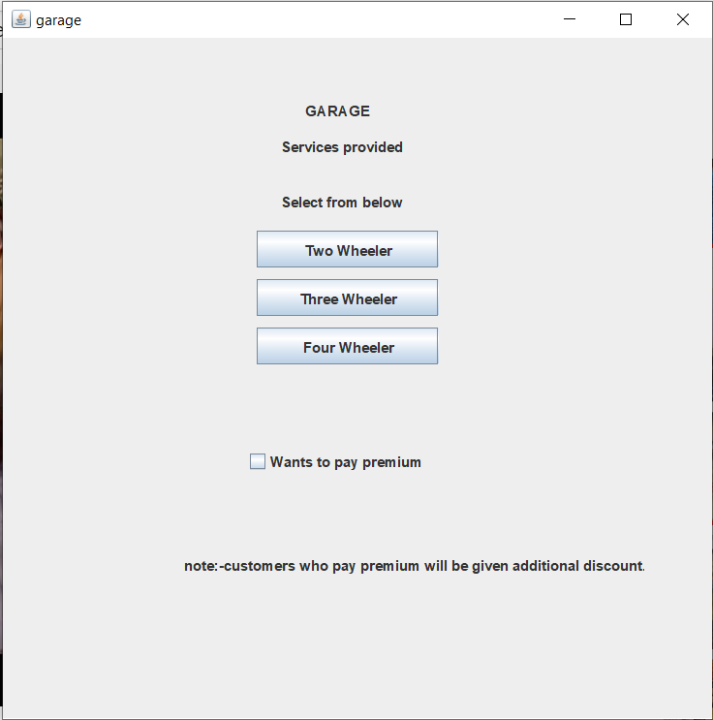

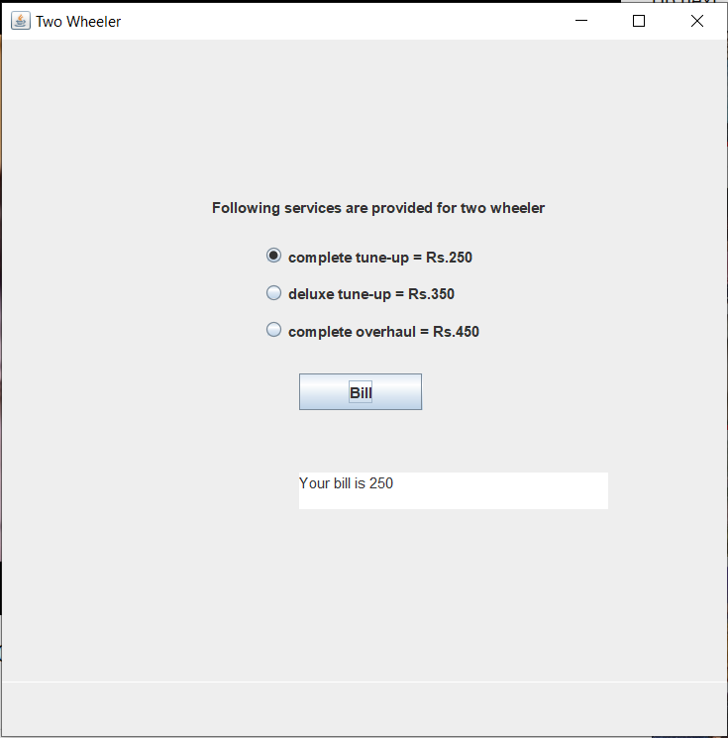

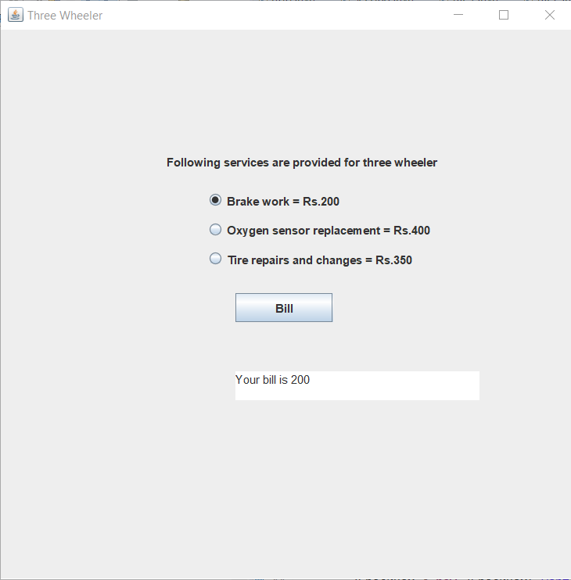

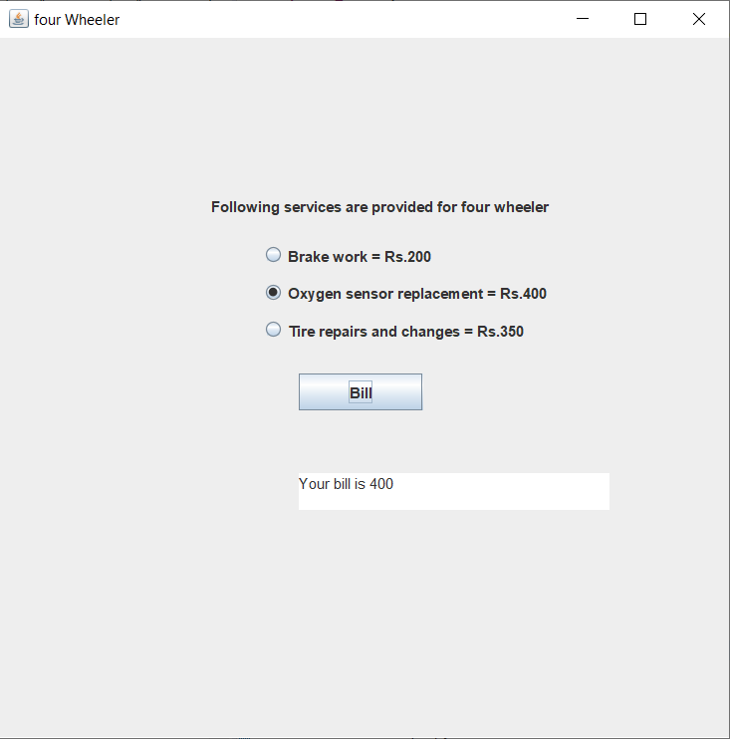

CLASS DIAGRAM:

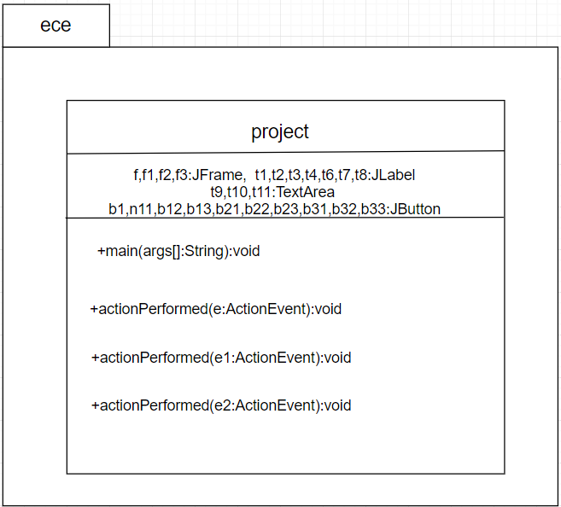

CONCLUSION

By using this program we can easily access the details offering to help the customer’s in every possible way. This graphical user interface also gives the user all the required details in a very clear manner.

From this program we graphically help the user to know the services clearly and is also much more interesting.